Created by: David Rubio G.
Blog: https://soceame.wordpress.com/
GitHub: https://github.com/DRubioG
Last modification date: 11/03/25

One of the problems of working with Microchip FPGAs/SoCs is the lack of information about certain tasks or functionalities that exist in Libero, and this is one of them.
A BIBUF is basically a Libero tri-state buffer (BIBUF stands for Bidirectional-Buffer).
This buffer is very important when implementing communication protocols such as I2C.
https://soceame.wordpress.com/2025/03/10/how-to-configure-i2c-on-a-smartfusion2/
This buffer has four ports, two input ports (D and E), one output port (Y) and one bidirectional port (PAD).
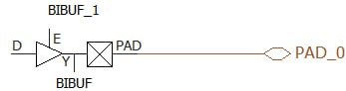
Of the input ports, D is the output of the FPGA and E is the port that selects whether it is input or output. The output port goes to the input of the FPGA, and the bidirectional port goes to the outside.
To connect it, follow a diagram like the following.
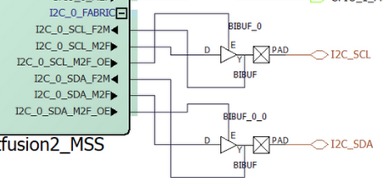
There is also a BIBUF for differential pins, called BIBUF_DIFF.
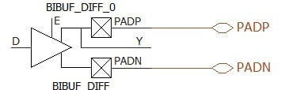
Finally, there is also a BIBUF for clock pins, called CLKBIBUF.
